xenoPMT v0.2
Engineering Guide
This documentation guide outlines the key points in the Project Management and Tracking system. Here you will kid the keywords and switches used in the background of the project.
Damian J. Suess – Xeno Innovations, Inc.
[2012-03-15]

Table of Contents
System Navigation 3
Defined Variables 4
Global Variables 4
Theme Page Variables 4
Modules 5
Members and Variables 5
Dashboard 7
Project Page 7
Navigation 7
Product 9
Tickets 10
User 11
Navigation 11
Customer 12
Navigation 12
Administrator 13
Settings 14
System Settings 14
User Settings 14

System Navigation

Well we got to start somewhere, might as well get started with the direction of the project.

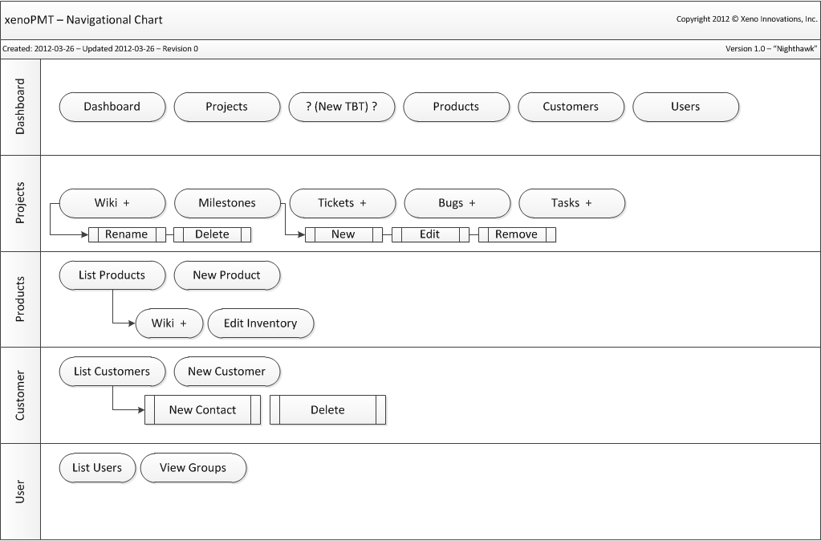
Application Variables

Defined Variables

This is a very short section but it has to be brought to attention. These are items throughout the PHP scripts in the project that are globally defined.

Value | Description | Code
DebugMode | Debug Mode | define("DebugMode", true);
DebugIndex | Used only to bypass the root “index.php” logic for debug testing purposes. | define("DebugIndex", false);
PMT_PATH | Absolute path of the installed folder | define('PMT_PATH',str_replace(pathinfo(__FILE__,PATHINFO_BASENAME),'',__FILE__));
THEME |  | define("THEME", $uri->Anchor("lib/themes", GetSetting("theme")));
PMT_VER |  | define("PMT_VER",$pmt_version);
PMT_TBL | Table header  Defined in “config.php” | define("PMT_TBL", $pmtConf["db"]["prefix"]);

Global Variables

These variables are used throughout the system as well. However in order to use them inside a function (i.e. your skins or modules) you must use the “global” setting. Most of these are from the classes which are defined in the pmt.php file (./lib/pmt.php).

Value | Description
$uri | Class – Uniform Resource Identifier.. in short, URL Parser.
$pmtDB | Class – Database
$user | Class – User class
$CACHE | (not used yet)
$BREADCRUMB | (not used yet)

Theme Page Variables

Value | Description
$PAGE_TITLE | String – used in <title>…</title> (not used yet)  Set this in, “config.php”
$PAGE_LOGO | Logo image (not used yet)
$PAGE_METABAR | Header toolbar
$PAGE_TOOLBAR | Toolbar code
$PAGE_MINILEFT | Mini tool options – left aligned (i.e. breadcrumbs)
$PAGE_MINIRIGHT | Mini tool options – right aligned (i.e. module node options)
$PAGE_HTDATA | String – Used to output data onto your skin.
$PAGE_PATH | Relative path to the theme directory

Modules

The modules are the driving force behind what you see on the screen. For each modules are basically the same thing you see in the URL such as project, client, user, etc. There are not many strict rules on creating modules to use as a custom URL, however the few that there are you must follow.

[1] All modules must use the interface, pmtModule (./lib/modules/pmtModule.php).
[2] All modules must contain a construct to accept the segment array, $uri->seg[] to parse where the URL is heading.
[3] Also there must be a member called, PageData() and this member must return the main http data to display in the web browser. This is then passed into $PAGE_HTDATA.

Members and Variables
These are the required members and variables which are used by other components of the xenoPMT system. This can be found in the interface, pmtModule.php.

Value | OOP Type | Return Type | Description
PageData | Member | String | Used to generate the page
Title | Member | String | Title of the page / module currently being viewed.  Used inside: <title>…</title>
Toolbar | Member | String | Returns the code used in the main toolbar  This must generate <ul> .. </ul>
MiniBarLeft | Member | String | Mini Toolbar Left Aligned  I.E. Breadcrumbs
MiniBarRight | Member | String | Mini Toolbar Right Aligned  I.E. Module node options (Wiki: edit, history, remove)

System Navigation

The goal of the web-based xenoPMT is to offer a variety of options for the products you offer and the projects that you or your business works on. After all, this is a project management and issue tracking system not just you’re your business but for your customers as well if you choose to do so. The ultimate goal of this project goes far beyond what this current version limits you to do. So let’s get started.

Available pages:
* Denotes root page lists all items if user access is allowed
- Dashboard (Main page)
- Project*
  - Tickets*, Bugs* and Tasks*
- Product*
  - Tickets*, Bugs* and Tasks*
- User*
- Customer*
- Administrator

Dashboard

URL example: “http://<installed-path>/”

Welcome page into the xenoPMT system. In the beginning versions of the software there will be generic welcome page which can be customized in the theme folder called, “main.php” (./pmt/lib/themes/<theme-name>/main.php).

Project Page

URL example: “http://pmt/project/” or “http://pmt/p/”

Project pages are used as the primary feature for project management and internal tracking of TBT items (Tickets, Bugs and Tasks). Remember, projects are not viewable to customers; only products are viewable to customers. Later on you will see how to branch “project” builds into “products” and how to link product issues into your projects. For all intents and purposes, projects are internal to your company and team structures only.

In this section you will learn about the following:
- Project URI structure under Navigation.
- Tickets, Bugs and Tasks
  - Purpose
  - Differences
  - Functionality
- * Linking Projects to Products
- * Linking Product bugs to projects.

Navigation

Product pages can access at either of the following, http://pmt/project/ or http://pmt/p/. The full name, “project” will probably be deprecated by the release of v1.0.

Here are the current suggested command switches that are handled by the URI project parser. Note that the paths beginning with “./” denote the root path of the project location. Root path being something like, “https://support.xenoinc.org/” or “http://www.yoursite.com/pmt/”. Below also note that anything marked, TBT, means “Ticket, Bug and Task”

The example below assumes the following:
- <project-name> “test”
- <ticket-id> or <id> “45”

Path | Depth | Description | Version
./p | 0 | Show project list | 0.2
./p/<project-name> | 1 | Show project stats (TBT) – (or wiki) | 0.2
./p/?cmd=new | 1 | Project – Create new (or use POST, not GET??)
./p/<name>/edit | 2 | Project – Edit details
./p/<name>/ticket | 2 | Ticket – View all tickets (all product versions) | 0.4
./p/<name>/bug | 2 | Bug – View all bugs | 0.6
./p/<name>/task | 2 | Task – View all tasks | 0.6
./p/<name>/[TBT]/new | 3 | [TBT] – New | 0.4
./p/<name>/[TBT]/<id> | 3 | [TBT] – Overview | 0.4
./p/<name>/[TBT]/<id>/edit | 4 | [TBT] – Edit main details | 0.4
./p/<name>/[TBT]/<id>/edit/<comment-id> | 5 | [TBT] – Edit comment <comment-id> | 0.6
./p/<name>/wiki | 2 | Wiki – Main page | 0.4
./p/<name>/wiki/<page-name> | 3 | Wiki – Sub page | 0.4
./p/<name>/wiki/<page>?cmd=edit | 3 | Wiki – Edit page (because “/” might be used in future) | 0.4
./p/<name>/roadmap | 2 | Roadmap – View all milestones | 0.8
./p/<name>/milestone | 2 | Roadmap – View all milestones | 0.8
./p/<name>/milestone/?cmd=new | 2 | Milestone – Create new
./p/<name>/milestone/<name> | 3 | Milestone – Display details and stats for milestone | 0.8
./p/<name>/milestone/<name>/edit | 4 | Milestone – Edit details | 0.8

Navigation – Mini-Bar Right

Below is the general layout of the “MiniBarRight()” as it’s known in the pmtModule interface. Inside the default theme skin it is defined using the following HTML code:
<div id="minibar_right" class="nav_right">
<!-- mini toolbar for module -->
<?php print($PAGE_MINIRIGHT); ?>
</div>

Minibar-Right Navigation

- List all projects (“”)
  - “Create Project”
- Project Viewer (“project-view”)
  - “New Milestone”, “Edit Project”, “Remove Project”
- Milestone Viewer (“milestone-view”)
  - “Edit Milestone”, “Remove Milestone”

Product

URL example: “http://<installed-path>/product/”

Product overview

This feature will not be field ready until at least version 0.7

Tickets, Bugs, Tasks

URL example: “http://<installed-path>/ticket/”

Most tickets will be accessible under the associated Product / Project page. However when creating a ticket from scratch, depending on your user access (customer or internal).

Integrate with TortoiseSVN or TortoiseGIT

As the project matures you will be able to easily integrate your source controlled projects with xenoPMT! Here is an example of the Properties and values. For more information see your TortoiseSVN/GIT user guide (Chapter 4.28)

Tickets
Property | Value
bugtraq:label | Ticket
bugtraq:logregex | (?:ticket: *|#)(\d+) *(?:, *(\d+))*
bugtraq:number | true
bugtraq:url | https://your.url.com/pmt/ticket/%BUGID%

Bugs
Property | Value
bugtraq:label | Bug
bugtraq:logregex | (?:bug: *|#)(\d+) *(?:, *(\d+))*
bugtraq:number | true
bugtraq:url | https://your.url.com/pmt/bug/%BUGID%

Tasks
Property | Value
bugtraq:label | Task
bugtraq:logregex | (?:task: *|#)(\d+) *(?:, *(\d+))*
bugtraq:number | true
bugtraq:url | https://your.url.com/pmt/task/%BUGID%
User

URL example: “http://<installed-path>/user/”

User page overview

This feature will not be field ready until at least version 0.5

Navigation

** Denotes, possible feature

Path | Depth | Description | Version
./user | 0 | User overview (sign-in / register)  If (logged in && admin) list all users  If (logged in != admin) this will take you to your page (./user/<name>)
./user/<user-name> | 1 | User – Dashboard  Projects, Stats (Tickets, Bugs, Tasks), List “Member Of”
./user/<name>/edit | 2 | User – Edit details
./user/<name>/tickets ** | 2 | User – [TBT] List open items
./user/<name>/projects **
./user/<name>/

Customer

URL example: “http://<installed-path>/customer/” or “http://<installed-path/c/”

Customer page overview

This feature will not be field ready until at least version 0.9 or v1.2.

Navigation

Path | Depth | Description | Version
./c | 0 | Customer dashboard (list, select, search) | 0.9
./c/<customer-id> | 1 | Show customer details and stats (TBT) | 0.9
./c/<id>/edit | 2 | Edit customer details
./c/<id>/tickets | 2 | List all tickets  [DTTM, Status (opened/closed), Product]
./c/<id>/bugs | 2 | List all bugs  [DTTM, Status (opened/closed), Product]
./c/<id>/tasks | 2 | List open tasks by date in table  [DTTM, id, product, .. ]
./c/<id>/products | 2 | List products owned by customer.  Table shows: Purchase date, Name, ID, Serial Number
./c/<id>/products/<customer-prod-id> | 3 | Show customer product details, registration date, updates, payments, etc.  Table: PMT_CUSTOMER_PRODUCT
./c/<id>/contact | 2 | Contact – List customer contact list
./c/<id>/contact/<id> | 3 | Contact – Show contact details
./c/<id>/contact/<id>/edit | 4 | Contact – Edit contact details

Administrator

URL example: “http://<installed-path>/admin/”

The administrator page is only accessible to those who are marked under group named, “ADMIN”. Customers cannot be used as an administrator; this would cause a major security threat.

Settings

DB Tables: PMT_SETTINGS, PMT_USER_SETTINGS

System settings are very important!

System Settings

This is a list of valid settings found in database table, PMT_SETTINGS.

Setting Name | Sample / Default value(s) | Description
theme | <Theme name>  Default: “default” | Theme name
locale | Language Code (en, en-gb, de, ..)  Default: “en” | Language setting

User Settings

Remember User Settings override system settings. Over time there may be user settings which do not exist in System Settings.

Below is a list of valid settings found in database table, PMT_USER_SETTINGS.

Setting Name | Sample / Default value(s) | Description
theme | <Theme name>  Default: “default” | Theme name
locale | Language Code (en, en-gb, de, ..)  Default: “en” | Language setting

